Christian Churches of God

No. CB141_2

Lesson:
The Feast of Tabernacles

(Edition 2.0 20090919-20210530)

In this lesson we will review the importance of the feast of Tabernacles in the plan of God and provide a variety of activities to reinforce the concepts.

Christian Churches of God

PO Box 369, WODEN ACT 2606, AUSTRALIA

E-mail: secretary@ccg.org

(Copyright © 2009, 2021 Christian Churches of God, ed. Wade Cox)

This paper may be freely copied and distributed provided it is copied in total with no alterations or deletions. The publisher’s name and address and the copyright notice must be included. No charge may be levied on recipients of distributed copies. Brief quotations may be embodied in critical articles and reviews without breaching copyright.

This paper is available from the World Wide Web page:
http://www.logon.org and http://www.ccg.org

Lesson:
The Feast of Tabernacles

Goal: To assist the children with knowing and understanding the meaning of the Feast of Tabernacles in the Plan of Eloah.

Objectives:
1. Children will be able to identify that Tabernacles is one of the three pilgrimage feasts.
2. Children will be able to identify how many days is the Feast of Tabernacles.
3. Children will be able to list which day of the Feast of Tabernacles is a High day.
4. Children will be able to state what the symbolism is for the Feast of Tabernacles in the plan of God.

Resources:
Joseph: The Son of Jacob Part 1 (No. CB14)
God’s Holy Days (No. CB22)
Tabernacles (No. CB34)
Preparing the Temple of God (No. CB35)
David, Nabal and Abigail (No. CB91)
Priesthood of Eloah from Messiah Onwards (No. CB118)
Sacrifices and Offerings of Eloah during the Millennium (No. CB121)

Memory Verses:
Leviticus 23:42-43 You shall dwell in booths for seven days; all that are native in Israel shall dwell in booths, ⁴³that your generations may know that I made the people of Israel dwell in booths when I brought them out of the land of Egypt: I am the LORD your God." (RSV)

Deuteronomy 31:10-13 And Moses commanded them, "At the end of every seven years, at the set time of the year of release, at the feast of booths, ¹¹when all Israel comes to appear before the LORD your God at the place which he will choose, you shall read this law before all Israel in their hearing. ¹²Assemble the people, men, women, and little ones, and the sojourner within your towns, that they may hear and learn to fear the LORD your God, and be careful to do all the words of this law, ¹³and that their children, who have not known it, may hear and learn to fear the LORD your God, as long as you live in the land which you are going over the Jordan to possess." (RSV)

Format:
Open with prayer.
Lesson on The Feast of Tabernacles (No. CB141).
Activity associated with the lesson.
Close with prayer.
Lesson:
- Read through the paper The Feast of Tabernacles (No. CB141) unless it is read as a sermonette with the children present.
- Children’s questions are in bold. This is a general review of the material covered in the lesson.

Q1. What is the third pilgrimage feast in God’s Calendar?
A. The Feast of Tabernacles.

Q2. Where in the Bible do we find the instruction for this feast?
A. In Leviticus 23:34-43.

Q3. How many days do we keep this Feast?
A. Seven days and the first day is a Holy Day.

Q4. After the seven days of the feast there is another Holy Day on the 8th day. What is this called?
A. The Last Great Day.

Q5. Where do we stay during the Feast of Tabernacles?
A. We stay in temporary accommodations like hotel rooms, rented houses, tents, etc.

Q6. Why do we have to go away from our homes to keep the Feast of Tabernacles?
A. When we travel, it reminds us we are sojourners, or just temporarily on this planet.

Q7. What special event occurs every 7th year of the cycle at the Feast of Tabernacles?
A. During every 7th year we read the Law of God.

Q8. Apart from every 7th year, is the Law read any other time?
A. Yes, in the 50th year which is the Jubilee.

Q9. Why do we have to read the Law?
A. We read the law so that we may hear, and learn, and fear the LORD our God, and obey all the words of His law.

Q10. What is the meaning or symbolism of the Feast of Tabernacles?
A. It pictures the coming Millennium or period of 1000 years when Messiah, along with those in the first resurrection, will be ruling or reigning on the earth.

Q11. The millennium is also termed the “Period of Just Rule”, why?
A. Because God’s government will be established here on earth and people will keep God’s laws and be blessed.

Q12. Where will Satan be during this time?
A. Satan will be bound and put away for almost the entire period of Just Rule.

Q13. What does the Feast of Tabernacles picture in the Plan of God?
A. The Feast of Tabernacles pictures the last 1000 years of the 7000-year period. We call this the millennium.

Q14. When Messiah returns and Satan is bound, what will happen?
A. Messiah will come as a king and take up rulership of the planet as the new Day Star or Morning Star of the earth and the nations will learn God’s way of life without the influence of Satan.

Q15. Will the Feasts be kept during the Millennium?
A. All of the feasts of God will again be restored in the 1,000-year reign of Messiah and the whole world will keep them. The punishment for disobeying and not listening and following Eloah’s law is very serious. (Zech. 14:16-19)

Q16. What is going to happen when Messiah returns to earth?
A. People who are baptized and obedient to Eloah’s laws will be brought to life at Messiah’s return to earth. The dead in Christ rise first and then those that are alive will be changed to spirit. This is the first resurrection (1Cor. 15:22-23; 1Thes. 4:15-17)

Q17. When does the Millennium begin?
A. Once Satan’s power has been removed, and he is bound for a time, the Millennium will begin.

Q18. What is significant about the year 2027?
A. It will be the end of the 120th Jubilee (6,000 years) since the closure of the Garden of Eden and the 50th Jubilee since the reconstruction of the 2nd temple in the time of Ezra and Nehemiah.

Q19. What is another name for the 50th Jubilee?
A. The Golden Jubilee.

Q20. Will people obey Eloah and His Law during the Millennium?
A. Yes, they will obey Eloah and His Law or they will endure the curses for disobedience. The faithful will send their representatives to the feasts in Jerusalem to learn more of how to keep Eloah’s laws.

Q21. Will a new Temple be built in the Millennium?
A. Yes, the Temple described in Ezekiel will begin to be built. The priests will be of the line of Zadok and functioning under Messiah. This will be the first time in history there will be a physical temple on the earth with Messiah functioning as its High Priest.

Q22. Will the world be the same in the Millennium?
A. No. We will have a world at peace with everyone striving to learn and keep God’s Laws. Isaiah describes a time when the nations are seeking God and the earth is full of the knowledge of God.

Activity:
Shema box (see below)
Supplies: Card stock, scissors, glue, copies of Life’s Spiritual First Aid kit, printed box template for each child (on the card stock), bandaids, tissues, rock salt, mustard seeds, cotton balls, life savers, pennies, toothpicks, clay, small eraser, chocolates, blue ribbons, decorating materials (optional).
Print one copy of the box (see below) on card stock for each child.
Cut on solid lines and heavily crease on dotted lines.
Glue the sides of the box first; once set, glue the bottom pieces. If the top flap is being colored it should be colored before the box is assembled.
Print a copy of Life’s Spiritual First Aid Kit for each child to go with the box. Allow the children to decorate the front with colours, markers, glitter glue, foamies etc.
Read through Life’s Spiritual first aid kit and allow each child to place each ingredient into their Shema Box.

Close with prayer.

Life’s Spiritual first aid kit
We have put together a special spiritual first aid kit to help remind you of God’s love and care for us all. Have a wonderful Feast of Tabernacles!
Love from The CCG Children

1 band aid – This is for all the scrapes that come our way that are healed by God.
(Ex. 15:26 RSV)

1 tissue – This is to remind us that God dries all of our tears of sorrow
(Isa. 35:10; Rev. 7:17; 21:4)

Salt – We are the salt of the earth and special to God
(Matt. 5:13)

Mustard seed – We need to remember that with faith nothing is impossible for us.
(Matt. 17:20)

Cotton Ball – This is to remind us that we need to make our robes as white as snow.
(Rev. 7:14)

1 life saver – This reminds us that Eloah is our saviour and redeemer.
(Isa. 43:11: Ps.3:8; 119:103)

Three pennies – These remind us that three times a year we are to appear before Eloah and give an offering
(Deut. 12:17-26)

Toothpick – To remind us to pick out every false and ungodly word and action.
(Ps. 119:103)

Clay – To remind us that Eloah is the master potter and we are to be mouldable.
(Isa. 45:9, 64:8; Jer. 18:1-6)

Small eraser – This helps us remember that Eloah erases our sins and puts them as far as east is from the west.
(Ps. 103:12)

Chocolate – Because with Eloah and His Law we learn the sweetness of life.
(Pro. 16:21, 27:9)
1 Rock – God is our rock.
(Isa. 26:4 RSV)

4 blue ribbons – To remind us that we are followers of God’s Law and His way of life.
(Num.15:38-41; Deut. 22:12)

But my God shall supply all your needs according to his riches in glory by Christ Jesus. Now unto God and our Father be glory for ever and ever. Amen (Phil. 4:19-20)

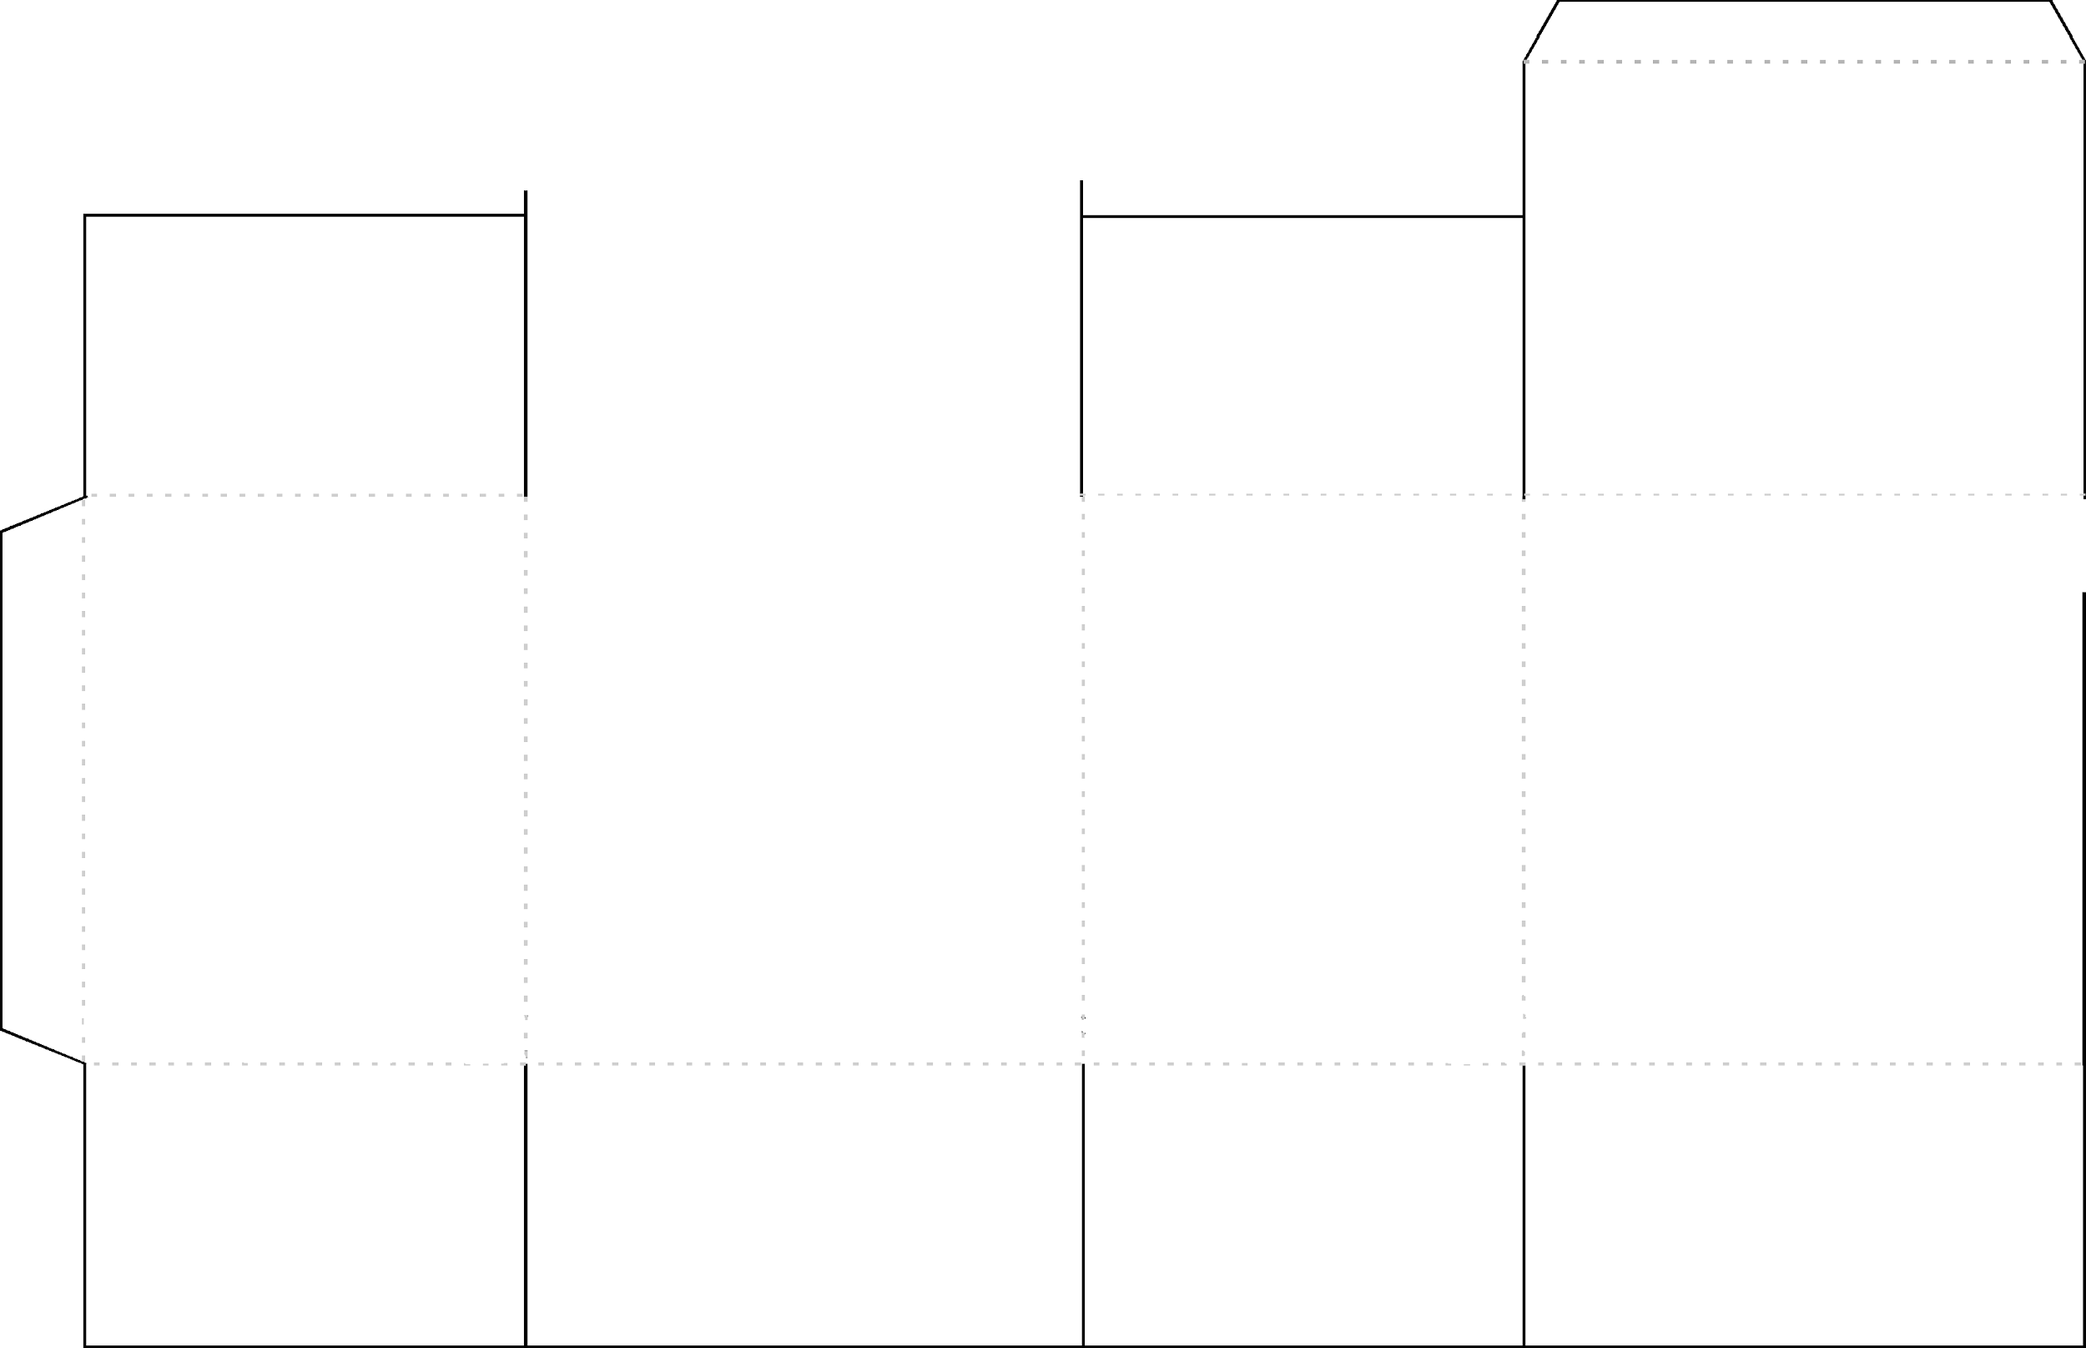
- Honor your father and mother that your days may be long in the land which the Lord God gives you.

- You shall not kill.

- You shall not commit adultery.

- You shall not murder.

- You shall not bear false witness against your neighbor.

- You shall not covet your neighbor’s house, wife, manservant, maidservant, beast of burden, or anything that belongs to your neighbor.

“Hear, Oh Israel: The LORD our God is one LORD.”

Deuteronomy 6:4

“You shall love the Lord your God with all your heart, and with all your soul, and with all your mind.

You shall love your neighbor as yourself.”

- You shall have no other gods before Me.

- You shall not make for yourself a graven image, or any likeness of anything that is in heaven above, on earth, or in the waters beneath to worship and serve.

- You shall not take the Lord’s name in vain.

- Remember the Sabbath day to keep it holy.

